Table of Contents
Page No.

I. Overview 1

II. Summary of Program Changes 12

III. Appropriations Language and Analysis of Appropriations Language 13

IV. Decision Unit Justification 14

A. Criminal 14
1. Program Description 15
2. Performance, Resources, and Strategies 16
3. Performance Tables 20
4. Program Increases 22
A. Border and Immigration Prosecution Initiative 22
B. Gang Prosecution Initiative 28
C. Project Safe Childhood Initiative 32

B. Civil 39
1. Program Description 40
2. Performance, Resources, and Strategies 41
3. Performance Tables 43

C. Legal Education 45
1. Program Description 46
2. Performance, Resources, and Strategies 47
3. Performance Tables 49

V. Exhibits

A. Organizational Chart
B. Summary of Requirements
C. Program Increases by Decision Unit
D. Resources by DOJ Strategic Goal/Objective
E. Justification for Base Adjustments
F. Crosswalk of 2006 Availability
G. Crosswalk of 2007 Availability
H. Summary of Reimbursable Resources
I. Detail of Permanent Positions by Category
J. Financial Analysis of Program Changes/Offsets
K. Summary of Requirements by Grade
L. Summary of Requirements by Object Class
M. Status of Congressionally Requested Studies, Reports, and Evaluations

I. Overview for the United States Attorneys

A. General Overview

1. Introduction

The United States Attorneys’ (USAs) mission supports two of the Department of Justice’s strategic goals - (1) prevent terrorism and promote the nation’s security, and (2) enforce federal laws and represent the rights and interests of the American people. The FY 2008 President’s Budget Request totals $1,747,822,000 and includes $20,973,000 for new enhancements. The request provides for an additional 203 positions and 102 FTE. The enhancements include requests for Border and Immigration Prosecution, Gang Prosecution, and Project Safe Childhood. These initiatives are described in greater detail in the Criminal Decision Unit section of this budget. Beginning in FY 2007, electronic copies of the Department of Justice’s congressional budget justifications and Capital Asset Plan and Business Case exhibits can be viewed or downloaded from the Internet using the Internet address: http://www.usdoj.gov/jmd/2008justification/.

The United States Attorneys serve as the nation’s principal litigators. In response to the mandates of the Constitution that required establishment of a system of federal courts, Congress enacted the Judiciary Act of 1789 directing the President to appoint in each federal district “a person learned in the law to act as an attorney for the United States.” Before 1870, the U.S. Attorneys acted independently, but since then they have worked under the direction of the U.S. Department of Justice.

There are 93 USAs located throughout the United States, Puerto Rico, the Virgin Islands, Guam, and the Northern Mariana Islands. The USAs are appointed by, and serve at the discretion of, the President of the United States, with the advice and consent of the United States Senate. The USAs report to the Attorney General, through the Deputy Attorney General. Each USA serves as the chief federal law enforcement officer within his or her judicial district, and as such is responsible for the prosecution of criminal cases brought by the federal government; the litigation and defense of civil cases in which the United States is a party; the handling of criminal and civil appellate cases before United States Courts of Appeal; and the collection of civil and criminal debts owed the federal government which are administratively uncollectible.

USAs provide advice and counsel to the Attorney General and senior policy leadership through the Attorney General’s Advisory Committee (AGAC) and its various subcommittees. The AGAC was established in 1973 to give USAs a voice in Department policies and to advise the Attorney General. The Committee meets monthly with the Attorney General and its 20 USA members represent various federal judicial districts, geographic locations, and small, medium and large size offices.

An order of the Attorney General in 1953 established the Executive Office for United States Attorneys (EOUSA) to provide executive assistance and coordinating functions for the USAs.

Under the direction of the Director of EOUSA, the mission is to provide the 93 USAs with general executive assistance and direction; policy development; administrative management direction and oversight; operational support; and coordination with other components of the Department and other federal agencies. These responsibilities include legal, budgetary, administrative, and personnel services, as well as continuing legal education. See Exhibit A for an organization chart of EOUSA. Specific offices and functions of EOUSA are outlined below.

- The Office of Counsel to the Director represents United States Attorneys’ Offices (USAOs) in communications with the Office of Legislative Affairs (OLA) and Office of Public Affairs (OPA), and serves as an ombudsman for USAOs with other Justice components. The Counsel’s office develops new programs and initiatives in the areas of legislation and public affairs, and provides expertise concerning substantive issues to the Director, EOUSA, the AGAC subcommittees and working groups. The Counsel’s office
responds to legislative comments, Congressional inquiries and letters, and assists in the preparation of testimony by USAs, AUSAs or their staffs.

- The Data Analysis Staff is responsible for providing a wide variety of reports and trend analyses for use by the Director of EOUSA when responding to requests from the Department, the Administration, Congress, and the public. The staff analyzes U.S. Attorney workyear, caseload and workload information for a variety of management purposes, and produces the United States Attorneys’ Annual Statistical Report. During FY 2006, the Data Analysis Staff responded to over 1,000 requests for trends, data, and management analyses.

- The General Counsel’s office provides advice to USAOs and to EOUSA on a broad array of legal and ethical issues. It provides guidance to USAO and EOUSA personnel regarding ethics and standards of conduct matters including conflicts of interest, recusals, outside activities, gifts and financial disclosures, allegations of misconduct, personnel legal issues, discovery requests and compliance with subpoenas. The General Counsel’s office is also responsible for the employee relations programs of EOUSA and the USAOs.

- Law Enforcement Coordinating Committee (LECC)/Victim-Witness Staff provide support through EOUSA for district LECC and Victim-Witness program activities through liaison, monitoring, and assistance activities. LECC coordinators at the district level carry out the important role of coordination and liaison with federal, state, and local law enforcement, and with members of the community on various crime reduction programs. Each District’s LECC is under the supervision of the United States Attorney who serves as the LECC chairperson or co-chairperson. Through the LECC program, training is provided to federal, state, and local law enforcement in areas such as anti-terrorism, gun crime, asset forfeiture, gang investigations, racial profiling, domestic violence, emerging drug trends, community policing, victim issues, and officer safety. USAOs’ Victim Witness personnel enhance and protect the necessary role of crime victims and witnesses in the criminal justice process, ensuring that the federal government does all it can to assist those individuals through an often extremely difficult process. Victim Witness personnel handle victim notification, explain to victims the criminal justice process, prepare victims and witnesses for testimony and allocution, coordinate their attendance at proceedings and attend proceedings with them, and provide victims with referrals and emergency assistance. Victims’ rights have taken on new importance since the passage of the Crime Victims’ Rights Act of 2004, which provided victims enumerated rights and, for the first time at the federal level, the mechanisms to enforce their rights. Victims are now playing a more central role in the criminal process, and exercising their rights in greater number than ever before. The number of notifications sent to victims alone has doubled since the Act passed.

- The Equal Employment Opportunity (EEO) Staff provides centralized leadership, coordination, and evaluation of all equal employment efforts within EOUSA and the USAOs. The EEO Staff is comprised of two components–complaint Processing and Affirmative Employment/Special Emphasis Programs.

- The Legal Programs office includes the Financial Litigation Staff (FLS) which assists in the collection and enforcement efforts of district financial litigation programs. FLS assists in the development of financial litigation policy, development and implementation of procedures and programs, and provides liaison functions within the Department and with outside agencies. The Legal Programs also coordinates asset forfeiture programs in USAOs and develops national policies and initiatives. In addition, Legal Programs coordinates the activities of the Affirmative Civil Enforcement (ACE) Program, which uses civil statutes for federal law enforcement efforts in fighting economic fraud.

- The Evaluation and Review Staff (EARS) conducts the evaluation program enabling the Director of the Executive Office to execute the responsibility of conducting reviews of internal management controls and prevent waste, loss, unauthorized use or misappropriation in federal programs, as required under the Federal Manager's Financial Integrity Act. The evaluation program provides on-site management assistance to the U.S. Attorneys. In FY 2006, EARS conducted 19 evaluation visits and 14 follow-up visits occurred to ensure that those issues identified as a result of the evaluation process were corrected. In FY 2005, EARS began the process of revising the administrative evaluation program to improve the effectiveness and consistency of the evaluation of the administrative functions within the USAOs by focusing on the “big picture” or “high impact” issues during the EARS reviews. The revisions to the EARS evaluation program will be fully implemented during FY 2007. During FY 2007, EARS has scheduled 23 evaluation visits.

- The Freedom of Information and Privacy Act (FOIA) Staff processes all FOIA and Privacy Act requests for records located throughout EOUSA and the USAOs, provides legal guidance to USAOs concerning FOIA/Privacy Act issues, represents them in administrative appeals, and assists Assistant United States Attorneys and Department of Justice attorneys in litigation in federal courts throughout the country by providing draft
pleadings and preparing legal documents. In FY 2006, the FOIA/PA staff processed 4,485 requests for information, an increase of 650 requests or 17 percent over 3,835 processed requests in FY 2005.
- The Office of Legal Education (OLE) develops, conducts, and authorizes the training of all federal legal personnel. OLE coordinates legal education and attorney training for the Department of Justice and other departments and agencies. OLE is a separate decision unit of this budget and its functions are discussed later in greater detail.

- The Chief Operating Officer (COO) is a key advisor to the Director, EOUSA, and the AGAC on nationwide issues, and manages and directs the following offices. The Employee Assistance Program (EAP) provides free, confidential assessment, short-term counseling, and community referrals for EOUSA employees and their families.The Facilities Management and Support Services Staff (FMSS) provides direct support and oversight of all USAOs in the areas of real property management, including space acquisition, relocation, design, repair, and management of rent payments. Support Services include acquisition and procurement, and coordination of records and forms management, printing, and mail metering. The Personnel Staff develops and maintains a component-wide personnel program covering attorney and support staff throughout the USAOs and EOUSA. The Security Programs Staff provides security program support for USAOs, including policy and procedural assistance, training, education and awareness efforts, and emergency and contingency planning.

- The Chief Information Officer (CIO) is responsible for providing advice and assistance to the Director and senior staff to ensure that Information Technology (IT) is acquired and managed within Department, EOUSA, and USAO policies and procedures. The CIO ensures the integration of IT into strategic planning, acquisition, and program management processes to support the mission of the organization. The CIO also directs and manages the Case Management Staff, which provides user assistance and technical support for the nationwide case management systems; the Office Automation Staff, which includes the purchase and installation of computer systems, equipment, and software, maintenance of hardware and software, and end-user training; and the Telecommunications and Technology Development Staff, which provides administrative and technical support to USAOs in all telecommunications activities, including voice data and video. In FY 2006, the IT program accomplished several goals related to improving case management, computer security and wide-area telecommunications. EOUSA completed the conversion to the Department’s wide area network initiative called JUTNET (Justice Unified Telecommunications Network). Information security was greatly improved by the establishment of a Security Operations Center in Columbia, South Carolina, which monitors all network traffic for computer virus and unauthorized access on a 24/7 basis. Major steps were accomplished towards the implementation of the Department’s new case management system. In addition, for Contingency of Operations (COOP) responses, two new remote access initiatives were implemented to provide secure access to critical information in the event of a natural disaster or terrorist attack.

- The Chief Financial Officer (CFO) through the Resource Management and Planning Staff (RMP) has responsibilities in the areas of budget formulation, budget execution, financial management, audit reviews, and long-range planning. RMP manages FTE allocations and a budget of approximately $1.6 billion on behalf of the USAs. The staff consolidates resource needs and formulates an annual budget submission for presentation to the Department, the Office of Management and Budget, and Congress, and manages the day-to-day financial operations through the accountability reports at the end of a fiscal year. The staff also develops performance measures for the USAs that are required with each budget submission in accordance with the Government Performance Results Act (GPRA).

CRIMINAL PROSECUTIONS

The United States Attorneys’ Offices investigate and prosecute a wide range of criminal activities and handle a more diverse workload than ever before. The offices’ caseloads include international and domestic terrorism, identity theft, child exploitation and obscenity, complex and time-consuming corporate fraud, firearms and violent crime, sensitive public corruption and organized crime, drug enforcement, immigration, and criminal civil rights enforcement. Many of these cases involve multiple defendants and are extremely complex. The nature of today’s crimes has required the United States Attorneys and Assistant United States Attorneys to become conversant in diverse fields such as the banking and health care industries, computer technology,
securities, foreign cultures and languages, and manufacturing processes affected by environmental and other federal regulations.

The USAOs handle the majority of criminal cases prosecuted by the Department of Justice. The USAs receive most of their criminal referrals, or “matters,” from federal investigative agencies including the Federal Bureau of Investigation, the Drug Enforcement Administration, the Bureau of Alcohol, Tobacco, Firearms and Explosives, the United States Customs Service, the United States Secret Service, and the United States Postal Service. USAOs also receive criminal matters from state and local investigative agencies, as well as violations reported by private citizens. After careful consideration of each criminal matter, the USAs decide the appropriateness of bringing criminal charges, and, when deemed appropriate, initiate prosecution. Except for misdemeanor offenses and instances in which an alleged offender waives the right to a grand jury indictment, the USAs present evidence against an alleged offender to a grand jury. The grand jurors decide whether to return an indictment. If an indictment is returned, the USAs then present the criminal charges in open court at the arraignment of the defendant.

Although historically a large number of criminal defendants enter a plea of guilty prior to trial, the USAs must always fully investigate the crime, prepare the charging document, and be prepared to go to trial. Consistent preparation for trial minimizes the risk of dismissal for noncompliance with the Speedy Trial Act and strengthens the government’s position in negotiations with defense counsel for a guilty plea. Pretrial discovery practice also strengthens the government’s position. When a guilty plea is not obtainable, a trial becomes necessary. The USAs then present factual evidence to convince the jury, or the judge in a non-jury trial, of the defendant’s guilt. If the defendant is convicted, the USAs must prepare and present evidence at the defendant’s sentencing hearing and then defend the conviction at post-trial hearings and appeals. The USAOs handle most criminal appeals at the intermediate appellate level. After filing a brief, the USAs may be required to participate in oral arguments before the United States Courts of Appeal. If there is a further appeal, the USAs may be called upon to assist the Department of Justice litigating divisions or the Solicitor General in preparing the case for review by the United States Supreme Court.

CIVIL LITIGATION

In the civil arena, the USAs initiate civil actions, or affirmative litigation, to assert and protect the interests of the United States. They also defend the interests of the government in lawsuits filed against the United States, referred to as defensive litigation. In other civil cases, the United States is a third party plaintiff or defendant, a creditor, or an intervener. These types of civil litigation represent the civil caseload nationwide.

The USAOs initiate civil actions, or affirmative litigation, to assert and protect the interests of the United States. Such affirmative litigation includes civil actions brought to: enforce the nation’s environmental, admiralty, and civil rights laws; represent the government’s interests in bankruptcy actions; recoup money and recover damages resulting from federal program and other fraud; enforce administrative summonses and asset forfeiture litigation, which involves assets seized by federal, state, and local law enforcement.

The USAs also represent and defend the interests of the government in lawsuits filed against the United States, or defensive civil litigation. Such litigation includes tort suits brought by those who allege suffering as a result of government action, adjudication of Social Security disability claims, alleged contract violations, habeas corpus petitions, and race, sex, and age discrimination actions. The USAOs represent and defend the government in its many roles – employer, regulator, law enforcer, medical care provider, revenue collector, contractor, procurer, property owner, judicial and correctional system manager, and an administrator of federal benefits. In those cases where the United States is sued, the USA must be its representative.

It is critical to note that civil defensive work is unique because it is non-discretionary and non-delegable. Unlike criminal units, civil units of USAOs cannot employ “declination” criteria to manage or reduce the civil defensive caseload. All cases filed against the government, its agencies, and employees in their official capacities must be defended.

Debts are ordered to be collected from a criminal defendant when the defendant is sentenced by the court. These debts may be in the form of restitution to victims of crime, fines imposed by the court to penalize criminals, special assessments on each criminal conviction count, costs of prosecution and other costs, and forfeitures of appearance bonds. Interest may also be collected in certain cases. In instances where restitution is ordered, the USAs are involved in collecting federal restitution payments, or restitution which is owed to the United States, and in collecting non-federal restitution, or that which is owed to private individuals and entities.

The USAs are the federal government’s debt collection attorneys, responsible for litigating civil debts for federal agencies. In FY 2006, the USAOs collected $5.24 billion of criminal and civil debts owed, a 48.3 percent increase over the $3.53 billion total collected in FY 2005. It is noteworthy that the collection effort, which is handled by a fairly modest percentage of the total workforce, results in nearly three times the amount of revenue to the Treasury than the $1.75 billion sought in the FY 2008 President’s budget request. Even if one were to add the budgets of the Department’s Criminal and Civil Divisions to recognize the contributions of those entities to this result, the investment would rise to approximately $2 billion, with a return well above that. As a result of the Mandatory Victims Restitution Act (MVRA), it is now mandatory for courts to impose monetary restitution orders in all violent crimes and most property crimes. USAs are required to enforce restitution orders on behalf of all victims of federal crimes. The amount of outstanding criminal debt has risen dramatically since the enactment of the MVRA to $45.7 million by the end of FY 2006, and of that amount, it is estimated that $11.4 million is collectible.

The U.S. Attorneys also are the legal representatives for other federal agencies to pursue repayment of the debts. For example, when federal agencies lend money and the recipients default on repayment of the loans, or federal agencies have paid on guaranteed loans and have not been repaid as provided for in the lending agreement, USAs pursue the repayment of debt. The Departments of Agriculture, Education, Health and Human Services, Housing and Urban Development, Transportation, Veterans Affairs, and the Small Business Administration are some of these client agencies. USAs file suit to obtain judgments to collect debts, foreclose on real property, compel physicians to either repay or fulfill their commitment to the Public Health
Service in return for education grants, sue to set aside fraudulent transfers of property which could be used to satisfy defaulted loans, and manage debtor repayment schedules.

In FY 2006, the USAOs recovered $1.52 billion in criminal debts compared to $1.15 billion in FY 2005, a 32.2 percent increase, and recovered $3.72 billion in civil debts compared to $2.38 billion in the previous year, an increase of 56.3 percent. The Financial Litigation Units (FLUs) are the components in each USAO charged with the responsibility for enforcing and collecting all criminal and civil debts in the district owed to the United States and non-government victims of crimes. The USAs also carry out the important role of liaison with federal, state, and local law enforcement officers, and with members of the community on various crime reduction programs.

CRIMINAL AND CIVIL APPEALS

Generally, appeals are very time-consuming, requiring a thorough review of the entire record in the case, the filing of a brief and reply brief, and in most cases participation in oral argument which requires travel to the city where the United States Court of Appeals for the circuit is located. Furthermore, the complexity of appellate work and the time required to handle that work increases when convictions are based on complex facts such as those found in organized crime drug enforcement and other narcotic cases, financial institution fraud, organized crime, armed career criminal, public corruption, health care fraud, and computer fraud cases.

The appellate workload of the United States Attorneys’ offices has increased due to additional appeals prompted by the Supreme Court’s ruling in United States v. Booker in January 2005, which held that the Sixth Amendment right to jury trial applies to factual findings supporting certain sentencing enhancements under the U.S. Sentencing Guidelines, and that the Guidelines are advisory instead of mandatory. As a result, post-sentencing motions filed by incarcerated defendants, primarily to vacate a sentence under the new guidelines, increased by 383 motions from 5,565 to 5,948 or 6.9 percent between FY 2004 and FY 2006. The number of motions pending also increased between FY 2004 and FY 2006, increasing by 9.2 percent from 7,642 motions pending to 8,346.

2. Issues, Outcomes, and Strategies

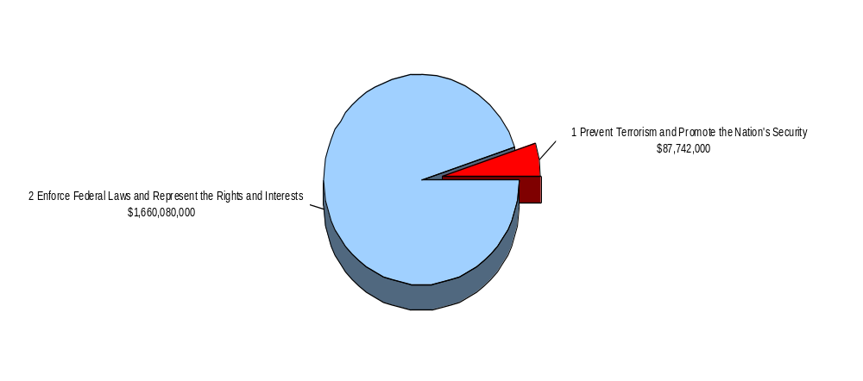
FY 2008 Total Request by DOJ Strategic Goal

The following is a brief summary of the Department’s Strategic Goals and Objectives, in which the USAs play a role.

DOJ Strategic Goal 1: Prevent Terrorism and Promote the Nation’s Security ($87,742,000

- Prevent, disrupt, and defeat terrorist operations before they occur (1.1)
- Investigate and prosecute those who have committed, or intend to commit, terrorist acts in the United States (1.2)

DOJ Strategic Goal 2: Enforce Federal Laws and Represent the Rights and Interests of the American People ($1,660,080,000)

- Reduce the threat, incidence, and prevalence of violent crime, including crimes against children (2.1)
- Reduce the threat, trafficking, use, and related violence of illegal drugs (2.2)
- Combat white collar, economic crime, and cybercrime (2.3)
- Enforce federal statutes, uphold the rule of law, and vigorously represent the interests of the United States in all matters for which the Department has jurisdiction (2.4)

3. Full Program Costs

This request funds the strategies that support the USAs’ objectives. We will continue to provide federal leadership in preventing and controlling crime and seek just punishment of those guilty of unlawful behavior.

FY 2008 Budget Request by Decision Unit

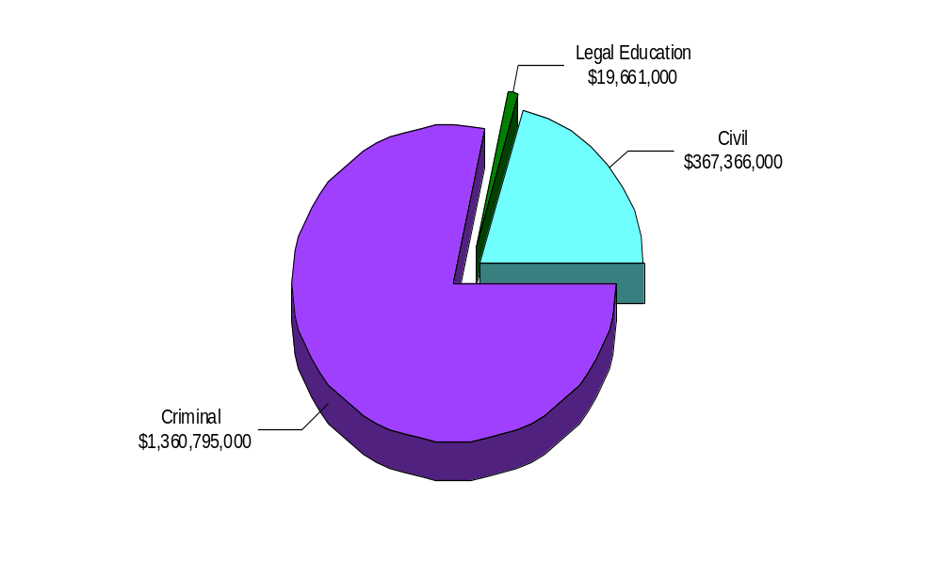

The USAs’ $1,747,822,000 budget request for FY 2008 is divided into three decision units: criminal, civil, and legal education. Some programs, as well as management and administration costs, cross decision units. Both performance and resource tables within each decision unit define the total costs of achieving the strategies the USAs will employ in FY 2008. The various resource and performance charts incorporate the costs of lower level strategies which also contribute to the achievement of objectives, but which may not be highlighted in detail in order to provide a concise narrative. Also included are the indirect costs of continuing activities, which are central to the operations of each decision unit.

4. Performance Challenges

The challenges that impede progress toward achievement of agency goals are complex and ever changing. New national priorities since September 11 have affected everyone in the law enforcement community as resources and personnel have been redirected to prosecute the Global War on Terror. Additionally, internal agency dynamics, political decisions, technological developments, and criminal behavior are factors that can impact law enforcement practices and pose challenges that demand attention. The basic mission of the U.S. Attorneys has been affected through a growing case backlog and reduced staffing levels. In FY 2004, 198 FTE were left unfilled, and that number more than doubled to 465 FTE by the end of FY 2005. By the end of FY 2006, unfilled FTE rose substantially again to 786 FTE. Criminal cases pending or backlog increased from 63,499 cases in FY 2003 to 70,232 in FY 2006, an increase of 6,733 cases or 10.6 percent. The number of new cases filed decreased by 4.5 percent over the last two fiscal years from 61,443 cases in FY 2004 to 58,702 cases in FY 2006. In order to address these challenges, the United States Attorney community has implemented substantial management and financial efficiencies.

External Challenges

It is more important than ever to have a highly skilled, dynamic workforce. Since September 11, USAOs have taken on more responsibilities in new areas. AUSAs coordinate with state, local, and federal agencies in preventing, investigating, and prosecuting terrorist acts. Furthermore, AUSAs participate in disaster planning and emergency preparedness. These coordination activities involve non-traditional roles for AUSAs and present a great challenge as we continue combating terrorism.

Coordination with state, local, and federal agencies is not unique to combating terrorism. USAOs are heavily involved in these activities in a variety of program areas ranging from gun violence reduction through Project Safe Neighborhoods to disrupting and dismantling drug organizations.

Emerging criminal activities, often driven by technology, such as cybercrime, and the economy are external challenges beyond our control, as downturns in the economy often correlate with increases in criminal activity. We will continue to focus on areas within our spheres of influence and control, concentrating on coordination efforts with state, local, and federal agencies and ensuring our workforce is trained for emerging, complex issues.

Internal Challenges

One internal challenge to the USAs organizations is keeping the workforce flexible and adaptable in a changing and dynamic environment. Over the past few years, terrorism, corporate fraud and internet-related crime have emerged as extremely important national priorities. The U.S. Attorneys responded by allocating positions to districts with the greatest need and providing necessary training through the National Advocacy Center (NAC). Continuous monitoring of case work and offices’ needs play an important role in our success.

II. Summary of Program Changes

For FY 2008, the U.S. Attorneys’ request is $1,747,822,000. The request includes $20,973,000 in enhancements and 203 new positions (102 FTE). The following enhancements that support Presidential priorities are requested: 1) Border and Immigration Prosecution, 2) Gang Prosecution, and 3) Project Safe Childhood.

Item Name | Description | Pos. | Atty | FTE | Dollars  ($000) | Page
Border and Immigration Prosecution | Provides for additional prosecution resources to address illegal immigration and other crimes along the nation's borders. | 72 | 55 | 36 | $7,400 | 22
Gang Prosecution | Supports prosecution efforts for the growing gang and resulting crime problem. | 38 | 30 | 19 | 4,079 | 28
Project Safe Childhood (PSC) | Focuses prosecution resources on child exploitation and pornography on the Internet. | 93 | 73 | 47 | 9,494 | 32
TOTAL |  | 203 | 158 | 102 | $20,973

III. Appropriations Language and Analysis of Appropriations Language

For necessary expenses of the Offices of the United States Attorneys, including inter-governmental and cooperative agreements, $1,747,822,000: Provided, That of the total amount appropriated, not to exceed $8,000 shall be available for official reception and representation expenses: Provided further, That not to exceed $20,000,000 shall remain available until expended. *

*The FY 2008 President’s Budget uses the FY 2007 President’s Budget language as a base, so all language is presented as new.

IV. DECISION UNIT JUSTIFICATION

A. CRIMINAL
United States Attorneys
Salaries and Expenses
(Dollars in Thousands)

Criminal Litigation | Perm. Pos. | Workyears | Amount
2006 Enacted w/Rescissions and Supplementals | 7,923 | 7,949 | $1,246,284
2007 Estimate | 8,079 | 8,033 | $1,269,649
Adjustments to Base and Technical Adjustments | ... | 72 | 70,173
2008 Current Services | 8,079 | 8,105 | $1,339,822
2008 Program Increases | 203 | 102 | 20,973
2008 Offsets | ... | ... | ...
2008 Request | 8,282 | 8,207 | $1,360,795
Total Change 2007-2008 | 203 | 174 | $91,146

1. Program Description–Criminal Decision Unit

The United States Attorneys' Offices prosecute a wide range of criminal activities and now handle a more diverse and complex workload than ever before. For example, criminal caseloads include: international and domestic terrorism, youth violence, complex and time-consuming health care fraud, financial institution fraud, immigration, computer fraud and environmental crime, public corruption and organized crime, drug enforcement, and cases involving multiple defendants and international organizations.

United States Attorneys receive most of their criminal referrals, or "matters," from federal investigative agencies or become aware of criminal activities in the course of investigating or prosecuting other cases. They also receive criminal matters from state and local investigative agencies. Criminal violations are also reported to the USAs by citizens. After careful consideration of each criminal matter, the USA decides the appropriateness of bringing criminal charges and initiates prosecution.

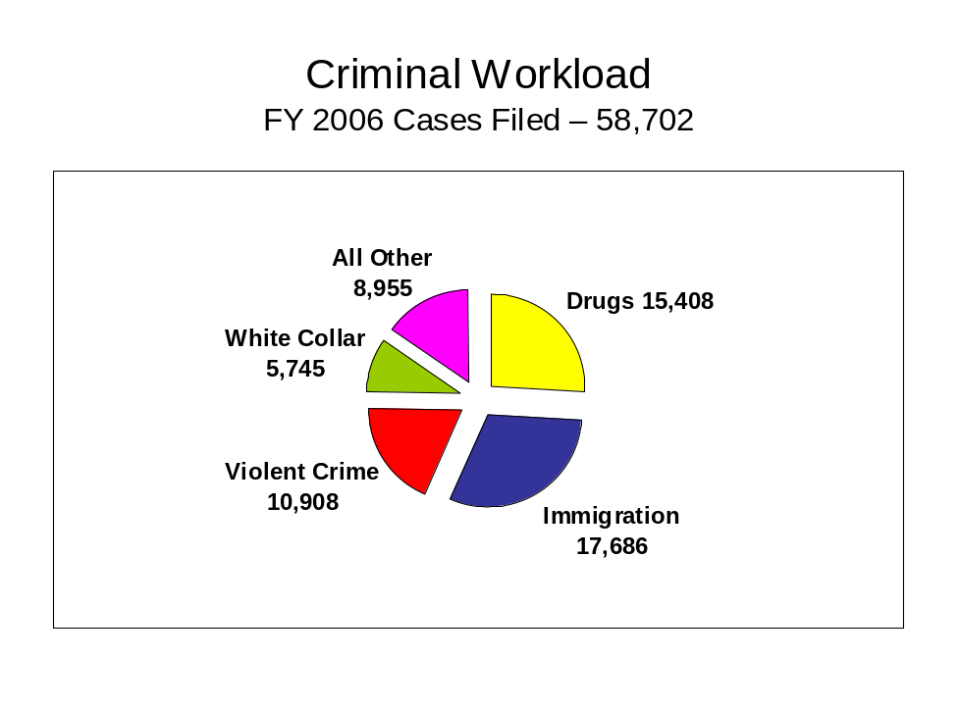

During FY 2006, the USAOs filed 58,702 criminal cases against 81,088 defendants in United States District Court. From FY 2004 through FY 2006, the number of cases filed, which include indictments filed in district court, fell 4.5 percent, from 61,443 to 58,702 cases. But while the number of cases filed has fallen, the number of cases pending has increased by 10.6 percent or 6,733 cases, up from 63,499 in FY 2003 to 70,232 in FY 2006.

A total of 60,393 cases against 82,343 defendants were closed during FY 2006. Of the 82,343 defendants whose cases were closed, 75,650, or 92 percent, either pled guilty or were found guilty. Of these, 63,006 received prison sentences, and 277 guilty defendants received sentences of life imprisonment. The rate of convicted defendants who received prison sentences has consistently exceeded 80 percent over the last six years.

2. Performance, Resources, and Strategies

The Criminal Decision Unit contributes to the Department’s Strategic Goal I: Prevent Terrorism and Promote the Nation’s Security. Within this goal, the decision unit’s resources specifically address two of the Department’s Strategic Objectives: 1.1 - Prevent, disrupt, and defeat terrorist operations before they occur; and 1.2 - Investigate and prosecute those who have committed, or intend to commit, terrorist acts in the United States.

The Criminal Decision Unit also contributes to Goal II: Enforce Federal Laws and Represent the Rights and Interests of the American People. Within this Goal, the decision unit’s resources specifically address five of the Department’s Strategic Objectives: 2.1- Reduce the threat, incidence, and prevalence of violent crime, including crimes against children; 2.2 - Reduce the threat, trafficking, and related violence of illegal drugs; 2.3 - Combat white collar, economic crime, and cybercrime; 2.4 - Uphold the civil and constitutional rights of all Americans, and protect vulnerable members of society; and 2.5 - Enforce federal statutes, uphold the rule of law, and vigorously represent the interests of the United States in all matters for which the Department has jurisdiction.

a. Performance Plan and Report for Outcomes

In the criminal area, there are two primary performance measures for the USAs, including
1) terrorism convictions, and 2) criminal cases favorably resolved.

1. Terrorism/Anti-Terrorism Convictions

The prevention of terrorist attacks and the prosecution of the war on terrorism remain the top priorities of the Department of Justice. In FY 2006, the United States Attorneys filed a total of 386 terrorism, anti-terrorism, and hoax and financing cases against 604 defendants. This includes international and domestic terrorism, terrorism-related financing, and terrorism-related hoaxes, as well as anti-terrorism cases. Anti-terrorism cases are those cases brought to prevent or disrupt potential or actual terrorist threats where the offensive conduct is not obviously a federal crime of terrorism. A total of 464 cases against 605 defendants were terminated in FY 2006.

The terrorism performance measure is the number of terrorism/anti-terrorism/financing and hoax convictions based on the definitions described above and derived from the U.S. Attorneys’ Case Management System. Included in the terrorism convictions are the original program categories of international terrorism and domestic terrorism. Examples of offenses that could be classified as
international or domestic terrorism include the following: destruction of an aircraft or interference with a flight crew; attack on a mass transit facility or on the means of interstate communication; use of weapons of mass destruction; and material support for terrorism. Terrorism-related hoaxes and terrorist financing were added after September 11, 2001 to allow the U.S. Attorneys’ Case Management System to capture more terrorism-related activities. Anti-terrorism cases are those where the underlying purpose or object of the case is to prevent or disrupt potential or actual terrorist threats where the offensive conduct is not obviously a federal crime of terrorism. In FY 2006, there were 105 terrorism convictions, 69 terrorism-related financing and hoax convictions, and 343 anti-terrorism convictions for a total of 517 convictions.

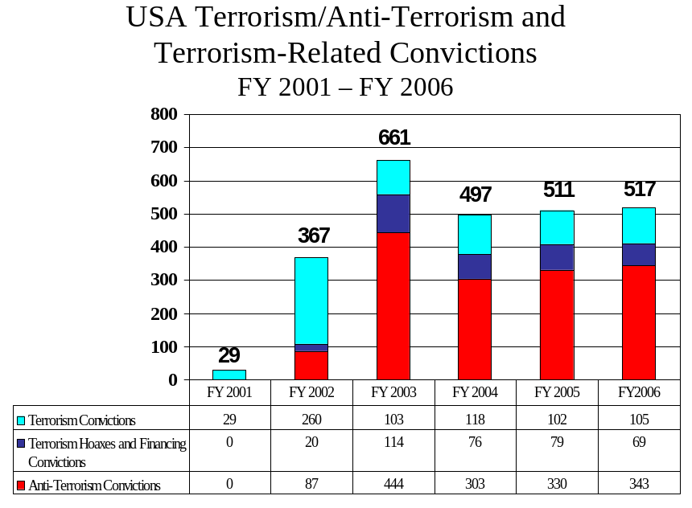

2. Criminal Cases Favorably Resolved

The USAOs investigate and prosecute a wide range of criminal activities. The USAs are called upon to respond to changing priorities and to become involved in specific crime reduction programs. After the events of September 11, 2001, the number one priority of the USAs became the prevention of terrorist acts and the investigation and prosecution of those involved in terrorist attacks. The USAs also have continued their longstanding commitment to address drug and violent crimes. Within the violent crime category, the USAs continue to address the illegal use of firearms by those who commit crimes and accompanying acts of violence in our communities. Drug prosecutions continue to be a priority of the USAs with particular emphasis on the operations of large drug organizations.

The USAOs handle most of the criminal cases prosecuted by the Department of Justice (DOJ). The USAs receive most of their criminal referrals from federal investigative agencies, including the Federal Bureau of Investigation (FBI); the Drug Enforcement Administration (DEA); the Bureau of Alcohol, Tobacco, Firearms and Explosives (ATF); the United States Customs Service; and the United States Secret Service. They may also receive criminal referrals from state and local investigative agencies or become aware of criminal activities in the course of investigating or prosecuting other cases.

In FY 2006, there were 75,133 defendants found guilty of non-terrorist criminal activity such as violent crime, drug trafficking, and white collar crime compared to 71,508 in FY 2005. The percentage of criminal cases favorably resolved in FY 2006 was 91.9 percent, compared to a goal of 92 percent. For FY 2007 and FY 2008, a 92 percent favorable resolution rate for criminal cases is planned. The FY 2008 goal for defendants found guilty will increase to 70,907, after decreasing in FY 2007.

b. Strategies to Accomplish Outcomes

In FY 2008, the U.S. Attorneys will continue to place a high priority on prosecution and security efforts in the war on terrorism. In addition, priority will be given to other new program enhancements requested for combating growth areas of criminal activity, such as prosecution of gangs, and child exploitation and obscenity. These strategies, discussed on the following pages, require a program enhancement of 203 positions (102 FTE) for a total of $20.973 million.

c. Performance Assessment Rating Tool (PART) Review

During FY 2004, the United States Attorneys’ were evaluated by the Office of Management and Budget (OMB) under the Performance Assessment Rating Tool (PART) process. The PART evaluated programs in four areas: purpose, strategic planning, program management, and results and accountability. The U.S. Attorneys received an “adequate” rating from OMB reviewers. OMB recommended that these follow-up actions warranted further review: 1) declination policies and practices, 2) enhancement of performance measurement and accountability of USAOs, and 3) common administrative functions in the USAOs in an effort to create efficiencies.

EOUSA has undertaken the following activities to address these follow-up actions. A working group of U.S. Attorneys and staff was appointed by the Director of EOUSA in August 2005 to draft new performance goals, measures and management standards in order to better evaluate U.S. Attorney district offices through the Evaluation and Review Staff (EARS) program.
Included in this review are district declination processes and the general performance and accountability of USAOs. The revised procedures adopted in FY 2007 will be used to make changes in the evaluation process of the USAOs and to address the PART recommendations. The working group made its recommendations to management in FY 2006 and policy decisions will be implemented for new evaluation reviews beginning in FY 2007. In addition, the Office Management and Budget Subcommittee of the Attorney General’s Advisory Council (AGAC) has reviewed the PART recommendations.

The Evaluation and Review Staff (EARS) program within EOUSA establishes on-site evaluation teams that gather information from client law enforcement agencies, the courts, and AUSAs. The evaluators make informed assessments whether USAOs declination policies, for example, are consistently applied and appropriate given the personnel resources, caseloads, and priority program demands in the district. The evaluation teams also review the level of supervision and documentation of declination decisions to ensure fair and consistent application of USAO declination policies. In addition, evaluators assess whether USAOs have adequate procedures in place for notification to other agencies and crime victims of decisions to decline criminal referrals. Reports of the evaluation teams are forwarded to the Director of EOUSA and the Deputy Attorney General (DAG) for their review and follow-up actions, if appropriate. Due to the unique situation of each USAO and the nature of the declination process, the current review system provides a good evaluation of the effectiveness of declination procedures in each district.

Efforts to enhance the performance and accountability of USAOs has been an on-going process by the Department of Justice and EOUSA. The DAG implemented a plan in November 2001 to improve the Department’s ability to assess the USAs’ efforts to address the Attorney General’s priorities and meet management and performance expectations. One aspect of the plan is to enhance the EARS evaluations to increase their effectiveness as a management tool. A second component of the plan is to better communicate Department priorities and effective management practices to USAs. A third aspect of the plan is improvement of data collection and analysis methods and systems.

Finally, in the area of efficiencies for common administrative functions, EOUSA maintains an extensive monitoring and review system of district budgets and expenditures. U.S. Attorney financial management personnel routinely participate in EARS evaluations of district offices, as well as on-site audit reviews. Administrative efficiencies resulting from the revised EARS evaluation process will be explored during FY 2007.

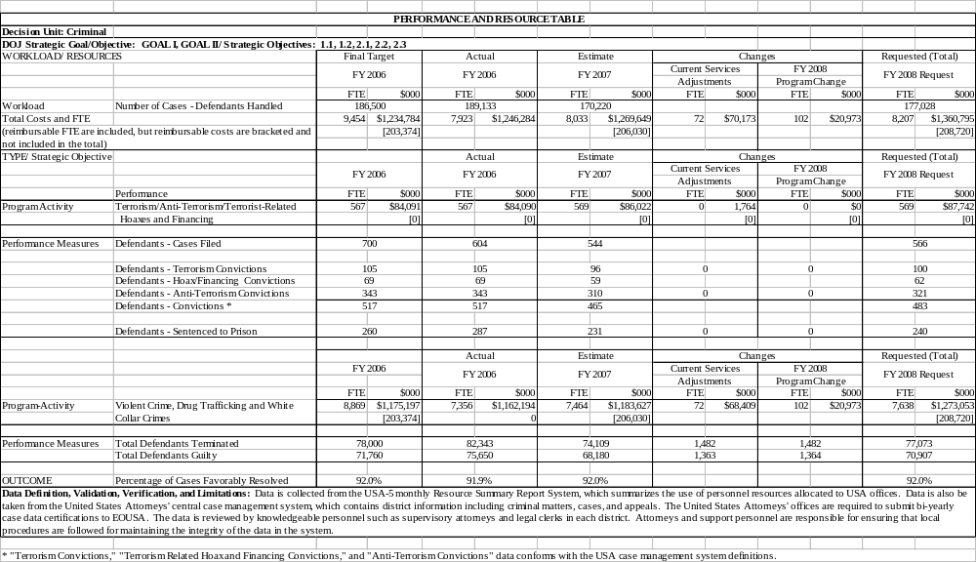

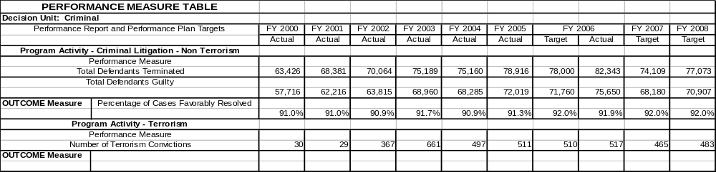

IV. Program Increases by Item

Item Name: Border and Immigration Prosecution Initiative

Budget Decision Unit: Criminal

Strategic Goal: 1) Prevent Terrorism and Promote the Nation’s Security.

Objectives: 1.1) Prevent, disrupt, and defeat terrorist operations before they occur.
1.2) Investigate and prosecute those who have committed, or intend to commit, terrorist acts in the United States.

Program Increase: Positions 72 FTE 36 Dollars $7,400,000
( 55 attorneys, 17 support)

Description of Item

In FY 2008, the U.S. Attorneys request $7.4 million for a Border and Immigration Initiative.
The request would provide 72 positions, including 55 attorneys and 17 support. Prosecutorial resources are needed to respond to the dramatic increase of immigration cases since FY 2000 and to be able to address the substantial increase of Border Patrol Agents proposed to protect our borders from illegal immigration. U.S. Attorneys’ Offices currently cannot meet the demands placed on them to prosecute immigration cases. The U.S. Attorneys’ strategies to combat violations of immigration offenses include:

- Ensuring that there is a sufficient United States Attorney (USA) presence to meet the steadily increasing caseload generated by increased law enforcement resources, and
- Aggressive enforcement of the immigration statutes, including aliens who after deportation attempt to reenter or are found in the United States illegally; alien smuggling organizations; and those involved in terrorism and violent crimes.

Justification

The goal of the current border enforcement strategy is to prevent illegal entries, particularly by terrorists or drug smugglers, through instituting a sufficiently recognizable level of deterrence along the border and by apprehending those who nevertheless seek to cross into the United States illegally. The United States Attorneys’ Offices in border districts are tasked to support federal law enforcement agencies that patrol 5,525 miles of the Canadian border and 1,933 miles of the Mexican border. Along the Northern and Southwest Borders, the U.S. Attorneys’ Offices have filed 51 percent more immigration cases between FY 2001 and FY 2006. Along the Southwest

Border alone, there were 11,820 criminal immigration cases filed in the five USAO districts in FY 2006, 67 percent of the national total, compared to 7,851 cases filed in FY 2001.

The Administration’s plans to increase the number of Border Patrol Agents by at least 6,000 over the next two years will impact the United States Attorneys’ workload dramatically. As a result of resources already provided for law enforcement resources along the border, the above data show that the number of immigration cases has already increased substantially over the last five years. The impact of 6,000 additional Border Patrol Agents will be even more dramatic.

A major concern in protecting our borders since 9/11 has been associated with stopping potential terrorists from entering the country. Given the fact that Al Qaeda, Hezballah, and other designated terrorist organizations have a presence in Canada and South America, national security is a paramount concern for United States Attorneys’ Offices along the border. Post-9/11 figures show that the staffing levels of the United States Attorneys’ Offices have not kept pace with the increasing caseload resulting from dramatic increases in federal law enforcement staffing.

The arrest of Ahmed Ressam, who was apprehended while attempting to enter the U.S. at Port Angeles, Washington and later convicted of a plot to detonate an explosive device at the Los Angeles airport, alerted America to its vulnerability along the U.S.- Canadian Border. Organizations engaged in or supporting terrorism have active cells and supporters within Southern Canada. An Al Qaeda affiliated Internet forum recently encouraged small groups of terrorists with explosives expertise to enter the United States from Canada to carry out attacks. Canada has relatively relaxed immigration laws, and is a “staging ground” for possible actions against the continental United States.

Given their location, the Canadian border districts play a significant role in our national defense against terrorism. The Northern District of New York, for example, has an extensive land and water border with Canada, and serves as the primary route of travel between the major cities of Canada and the Eastern Seaboard of the United States. In addition to Montreal, the Canadian cities of Ottawa, Toronto, Kingston, Cornwall, and Quebec are within easy driving distance of the Northern District of New York, the Western District of New York, Vermont and Maine, allowing access to the entire East Coast. The Detroit/Windsor border crossing is another location where countless individuals with ties to terrorist organizations cross between the two countries, often requiring prosecutive action to be undertaken through the local United States Attorney’s Office.

Law enforcement and national security concerns exist all along the Canadian border. Adnan El Shukrijumah is currently one of the FBI’s most wanted terrorists. He has completed advanced training at Al Qaeda’s camps, and pledged “bayat” to Usama Bin Laden. El Shukrijumah was
recently reported to have been living outside of Toronto under the alias Ciro Vitolo. An
individual using this name is reported to have entered the United States from Canada at Buffalo
New York on various occasions in 2005 and 2006. Data from the Canadian border districts show a significant increase in activity since 9/11. Between FY 2001 and FY 2006, immigration case filings in Canadian border districts has increased almost 60 percent, and the increases are not concentrated in any one district. Between FY 2001 and FY 2006, 14 of the 17 Canadian border districts had their immigration case filings increase.
The Southwest Border is a particularly vulnerable region where cross-border criminal enterprises occur. These criminal enterprises engage in human smuggling through Mexico into the United States that puts hundreds of millions of dollars into criminal hands — and the drug trade is much larger. The related crimes that occur — the killings, hostage taking, robberies, money laundering — are all methods that criminals employ in order to gain and expand market share and maximize profit in their criminal business enterprises. Most of these activities involve the illegal movement of people or goods across the Nation’s borders. In FY 2006, Border Patrol agents along the Southwest Border apprehended over 1 million aliens attempting to enter this country illegally. To address this issue, the Department of Homeland Security and Bureau of Customs and Border Protection have increased their permanent staff by more than 500 agents for the Tucson, Arizona sector alone.

The criminals who traffic in drugs or human beings and make their profits through illegal crossings are increasingly targeting Border Patrol Agents in violent attacks as the Department of Homeland Security’s border enforcement grows. “Rocking” (rock throwing) incidents continue to rise along the border, and even more disturbing is that federal agents working at or near the border have been murdered. These acts highlight the threat of armed drug smugglers coming through the border ready, willing, and able to confront law enforcement in order to pass their cargo to its intended destination.

National Park Service Ranger Kris Eggle was murdered after he intercepted one of a group of carjackers who drove across the Arizona border while being chased by Mexican police in a stolen car. Border Patrol Agent Alexander Kirpnick was murdered when he confronted a group of individuals who were backpacking drugs into the United States. In June 2005, two Border Patrol Agents were ambushed as they were moving in to intercept a group of backpackers carrying drugs into the United States. Multiple shooters who had been guarding the backpackers opened fire with assault rifles and seriously wounded both agents, who were fortunate to survive. A similar ambush occurred early in 2006 as agents were attempting to intercept a group of drug backpackers. Fortunately, the agents escaped injury in that incident. Similar ambush incidents have targeted the U.S. Custom and Border Protection’s (CBP) Shadow Wolves unit on the Tohono O’Odham Indian Reservation.
When confronted, these smugglers turn to violence to escape. In one case, the smuggler shot and wounded a Border Patrol Agent after being pulled over. The ensuing chase and shootout resulted in the death of a juvenile smuggled alien who was being transported in the trunk of the defendant’s vehicle. The Arizona U.S. Attorney’s Office obtained a conviction against defendant Shane Bobby Chiago in that case and he was sentenced to 18 years of imprisonment. In another case, the smugglers fled from local police, driving over 15 miles at speeds exceeding 100 miles per hour, running red lights and driving into oncoming traffic, until the smugglers crashed head-on into a car occupied by two newlyweds. The crash killed the newlyweds as well as three of the fifteen aliens who were being transported. The U.S. Attorney’s Office obtained a conviction after trial against Jose Luis Zepeda-Cruz and Jimir Valle Martinez. In September 2006, Martinez received a 35 year sentence.

These types of incidents demonstrate that threats to law enforcement personnel and criminal activity is growing as a result of the increased activity of violent drug traffickers and human smugglers. Violence among smugglers has also grown exponentially. For example, since 1999 a pattern has emerged in which alien smugglers will hijack loads of aliens from other smugglers. The criminal motives for these hijackings vary, but generally involve efforts to extort additional money from the aliens’ families or simply to reap the profit from the other smugglers’ successful efforts in getting the aliens across the border and through the security network. There have been numerous cases along the border in which carloads of illegal aliens have been hijacked.

Smugglers have turned to violence to extort payment from their own clients. In some instances, when a smuggled alien cannot pay the full amount, the smugglers use violence to convince the alien or family members to pay the smuggling fee. In other cases, the smugglers agree to a certain price for their services, but when the alien arrives at a drop house in the United States the fee is raised dramatically, often to a price that the alien cannot afford. Smugglers use threats and actual violence to compel payment. Often these threats are backed up by the presence of firearms, other weapons, and physical abuse.

Another significant threat to the border and the interior of the United States is posed by transnational street gangs. Many members of violent street gangs are foreign-born persons who are actively involved in crimes such as human and contraband smuggling, robbery, extortion, rape, and murder. The foreign nationals who belong to these gangs ignore our immigration laws, and they enter the United States illegally. They then travel to the Nation’s interior cities to join with other gang members and participate in criminal activity. The border violators today are better armed, more willing to use force, and thus the stakes are getting higher as the barriers are strengthened against illegal crossing of our borders.

In response to the growing problem of violence, USAO border districts are working closely with various components of the Department of Homeland Security (DHS), including U.S. Immigration and Customs Enforcement (ICE) and CBP, components from the Department of Justice, including the Federal Bureau of Investigation (FBI), the Drug Enforcement Administration (DEA) and the Bureau of Alcohol, Tobacco, Firearms and Explosives (ATF), and state and local law enforcement agencies and prosecutors’ offices to develop prosecutorial programs and policies to ensure the most efficient handling of violent cases and to achieve the most appropriate sentences in the best forum.

DHS has recently established Border Enforcement and Security Task Forces (BESTs), which build on their experiences fighting violent cross-border crime in Laredo, Texas, during “Operation Black Jack.” “Operation Black Jack” has been a focused effort to coordinate ICE, CBP, DEA, FBI, ATF, the U.S. Marshals Service, and other state and local law enforcement
agencies, with significant support from the Southern District of Texas USAO and the District Attorney’s Office. BESTs focus on every element of the enforcement process, from interdiction
to prosecution and removal, with the goal of eliminating the top leadership and supporting infrastructure that sustains these cross-border organizations. They leverage federal, state, tribal, local, and intelligence entities to focus resources on identifying and combating emerging or existing threats.
A similar effort has been undertaken along the Northern Border where DHS, the Royal Canadian Mounted Police, and other state, local, and provincial law enforcement agencies have formed 15 integrated Border Enforcement Teams (IBETS). The IBETS identify and target smuggling operations along the Canadian Border from Washington to Maine. As along the Southwest Border, the USAOs play an integral and critical role in these collaborative efforts from the investigative phase through the successful prosecution of cases developed by the IBETS.

The Department of Homeland Security’s Secure Border Initiative (SBI) incorporates these border enforcement efforts with interior immigration enforcement to create a seamless strategy to reduce and deter illegal migration into the United States, and in turn reduce the level of violence at the border. USAOs are an integral part of these collaborative efforts and prosecute those charged with federal crimes.

USAOs cooperate closely with state and local counterparts to ensure the best possible result in a given case. USAOs coordinate prosecution efforts with local prosecutors to ensure that the smugglers are prosecuted for charges that best fit their crimes and in the forum with jurisdiction over those charges. In some cases it has been appropriate to file charges both federally and in state courts, and the USAOs have worked closely with their local counterparts to achieve successful concurrent prosecutions, in turn maximizing the length of sentences for defendants.
As a catalyst in bringing a variety of law enforcement organizations together, the U.S. Attorneys are playing an integral part in providing the coordination necessary in focusing efforts to reduce the growing violence along the border states.

Impact on Performance

Sufficient United States Attorney presence along the border is needed to prosecute the expected, dramatic increase in cases brought on by stepped up enforcement efforts. The current level of USA resources along the border has not grown sufficiently to meet the present immigration caseload. Additional resources are needed by the U.S. Attorneys to aggressively pursue prosecution of crimes committed along the border. The increase of 6,000 Border Patrol
Agents and the resulting arrests requiring prosecution will severely strain the resources of the border districts. Additional prosecutors and contract support will be needed to address the resulting workload.

This initiative will address the Department's Strategic Goal I, Prevent Terrorism and Promote the Nation's Security and two objectives, 1.1- Prevent, disrupt, and defeat terrorist operations before they occur; 1.2- Investigate and prosecute those who have committed, or intend to commit, terrorist acts in the United States.

Border and Immigration Prosecution Funding
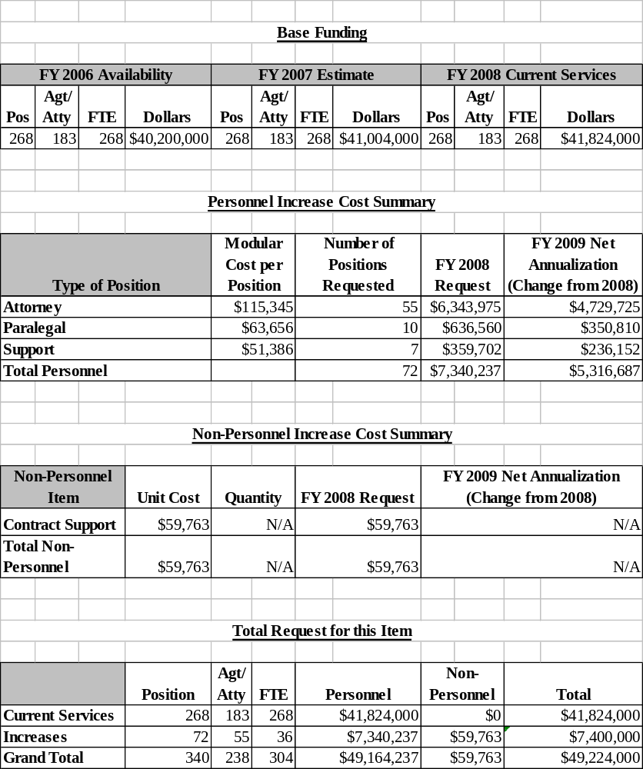

IV. Program Increases by Item

Item Name: Gang Prosecution Initiative

Budget Decision Unit: Criminal

Strategic Goal: 2) Enforce Federal Laws and Represent the Rights and Interests of the American People

Objectives: 2.1) Reduce the threat, incidence, and prevalence of violent crime, including crimes against children.
2.2) Reduce the threat, trafficking, use, and related violence of illegal drugs

Program Increase: Positions 38 FTE 19 Dollars $4,079,000
(30 attorneys, 8 support)

Description of Item

In FY 2008, the U.S. Attorneys request $4.079 million for a Gang Prosecution Initiative. This will provide for a total of 38 positions (19 FTE), which includes 30 attorney and 8 paralegal support positions. The Gang Prosecution Initiative supports the Attorney General’s efforts to combat gang violence and reduce crime by providing additional prosecutorial resources to address the growing gang problem throughout our country.

Gang violence is a problem in every state. It affects the quality of life across the country – from the largest cities to suburban communities and rural areas. Once found principally in large cities, violent street gangs now affect public safety, community image, and quality of life throughout the country. Gang violence is a complex issue that manifests itself in many different ways. Through a unified and cohesive effort of federal, state and local law enforcement, backed by additional resources, gang members can be brought to justice.

Justification

The presence of gangs throughout society is undeniable. They incite fear and violence within our communities. Gangs threaten our schools, our children, and our homes. Gangs today are more sophisticated and flagrant in their use of violence and intimidation tactics. In July 2003, the National Drug Intelligence Center’s Gangs and Drugs in the United States reported that gangs, whether street gangs, outlaw motorcycle gangs, or prison gangs, are the primary distributors of drugs throughout the United States. They are involved in drug distribution at both the wholesale and retail/street levels.

According to the 2004 National Youth Gang Survey published in April 2006, there were 760,000 gang members and 24,000 gangs active in the United States in 2004. A total of 173 cities with a population of 100,000 or more reported a gang problem in 2004. The number of gang homicides recorded in these cities was 11 percent higher in 2004 than the previous eight year average.

On April 21, 2005, Attorney General (AG) Alberto R. Gonzales announced several steps that the Department of Justice (DOJ) will take to strengthen Department-wide efforts to combat gang violence and reduce crime. He established the Attorney General’s Anti-Gang Coordination Committee, which directs the U.S. Attorneys to lead the Anti-Gang effort, appoint an Anti-Gang Coordinator, and implement individual strategies to combat gang problems in each district. The goal is to achieve measurable reductions in gang activity and violent crime by identifying the gangs posing the greatest danger to American communities, and targeting them with the coordinated resources of federal, state, and local law enforcement. The AG’s Anti-Gang Initiative also expands upon the traditional, law enforcement responsibilities of prosecutors, by emphasizing prevention and reentry activities. The Anti-Gang Coordinator is directed to coordinate these types of activities in each district. This expansion of duties requires an expansion of resources.

The Attorney General announced on February 15, 2006 a comprehensive new anti-gang program in six cities that will help us to combat some of the worst, most violent gangs in the country. These cities include: Los Angeles; Cleveland; Dallas-Fort Worth; Milwaukee; Tampa; and the “222 Corridor” that stretches from Easton to Lancaster, Pennsylvania, near Philadelphia. The program will focus on three areas: prevention, targeted enforcement, and prisoner re-entry. The cornerstone of the program is to make the U.S. Attorney the convener, who will work with each local community to design and implement programs that are uniquely tailored to its needs, while maximizing the impact of national resources and expertise.

An effective federal, state, and local law enforcement partnership is an essential building block for these investigations. U.S. Attorneys will participate with state and local community leaders to develop innovative solutions and better coordinate resources to deal with the unique gang problem facing each community.

On May 2, 2006, the Attorney General directed each United States Attorney to host a gang prevention summit that will bring together law enforcement and community leaders to discuss current, effective programs, identify gaps in services, and develop a plan for working in partnership to prevent youth from joining gangs. The United States Attorneys’ intend to hold violent gang offenders accountable for their actions.

Different regions of the country are dealing with diverse gang activity. For example, the violent gang Mara Salvatrucha, or MS-13, has a significant presence in Northern Virginia, New York, California, and Texas, as well as places as disparate and widespread as Oregon City, Oregon, and Omaha, Nebraska. MS-13 is estimated to have around 10,000 hardcore members and is growing increasingly sophisticated and violent.

The following are examples of USAO gang cases:

- A 38 count indictment charged that 49 Milwaukee Latin Kings gang members operated as a criminal RICO enterprise in Milwaukee and other parts of Wisconsin from January of 1998 through September 2005. The indictment contained specific allegations regarding 4 murders and 38 attempted murders committed by the defendants.

- In the Northern District of Illinois 56 alleged New Breeds street gang members and associates were indicted in a conspiracy to distribute powder and crack cocaine, heroine and marijuana.

- Over the past two years, more than 30 members of the MS-13, 50 members of the Bloods and four members of Murder Unit have been convicted on federal charges by the Eastern District of New York, including murder in the aid of racketeering, aggravated assault, narcotics distribution, firearms trafficking and immigration offenses.

In addition to their prosecution efforts, virtually all USAOs provide training related to gangs as part of PSN or anti-terrorism programs. The Executive Office for United States Attorneys (EOUSA) hosted a symposium in Washington, DC on March 1, 2005 to discuss best practices in combating sophisticated gangs. The United States Attorneys from 11 districts, the special agents in charge from the Federal Bureau of Investigation, Drug Enforcement Administration, and the Bureau of Alcohol Tobacco and Firearms, as well as the police chiefs, and U.S. Marshals in those districts attended the symposium. EOUSA used this opportunity to discuss the development of additional gang-related training through the National Advocacy Center (NAC) and other vehicles.

Impact on Performance

The requested resources will be used to support Goal II of the Department’s Strategic Plan, Enforce federal laws and represent the rights and interests of the American people, and objectives 2.1, Reduce the threat, incidence, and prevalence of violent crime, and 2.2, Reduce the threat, trafficking, and related violence of illegal drugs.

Additional resources will better position the United States Attorneys with the necessary tools to assist in the achievement of the Department’s goals in responding in a coordinated effort to the growing gang problem. The additional FTE requested for the Gang Prosecution Initiative will be used to support gang prosecution efforts, including contract support.

Gang Prosecution Funding
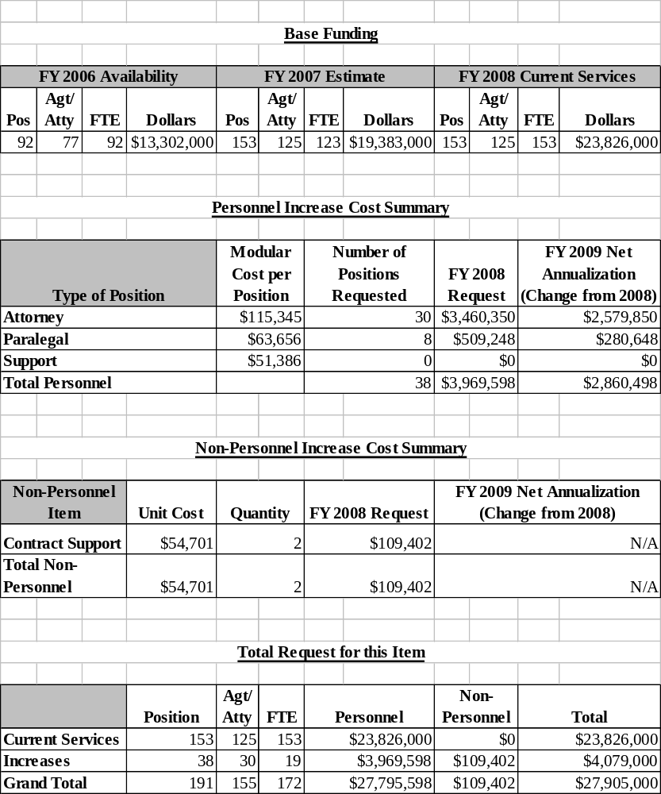

IV. Program Increases by Item

Item Name: Project Safe Childhood Initiative

Budget Decision Unit: Criminal

Strategic Goal: 2) Enforce Federal Laws and Represent the Rights and Interests of the American People.

Objectives: 2.1) Reduce the threat, incidence, and prevalence of violent crime, including crimes against children.
2.3) Combat white collar crime, economic crime, and cybercrime.

Program Increase: Positions 93 FTE 47 Dollars $9,494,000
(73 attorneys, 20 support)

Description of Item

In FY 2008, the U.S. Attorneys request $9.494 million for a Project Safe Childhood Initiative. This will provide for 93 positions (47 FTE), which includes 73 attorney, 3 paralegal, and 17 support positions. The positions will be dedicated to implementing the Attorney General’s Project Safe Childhood (PSC) initiative and to prosecute the ever-increasing number of child exploitation and pornography cases across the nation.

Child exploitation and pornography are profound evils that exploit children, shatter lives, and rob youth of their innocence. Our society has a duty to protect children from exploitation and danger and to tirelessly pursue those who commit these heinous crimes. There is no place for complacency when it comes to protecting our children. The Attorney General’s priorities include a high-profile strategy of preventing crimes against children by enforcing laws against obscenity, child pornography, and other child exploitation crimes. Accordingly, Attorney General Alberto R. Gonzales announced Project Safe Childhood on February 15, 2006. He formally kicked off this comprehensive and coordinated robust response to combat the online exploitation and victimization of children on May 17, 2006.

Project Safe Childhood is modeled on the blueprint of the successful Project Safe Neighborhoods (PSN) initiative, a nationwide program started in 2001 to reduce gun crime in America. As with PSN, PSC creates, on a national platform, locally designed partnerships of federal, state, local and tribal law enforcement officers in each federal judicial district to investigate and prosecute Internet-based crimes against children. Each U.S. Attorney will designate a PSC coordinator. Each coordinator will build partnerships, develop strategic plans and implement accountability measures. With the U.S. Attorney as the convenor, each local community will be able to design and implement programs that are uniquely tailored to its needs, while maximizing the impact of national resources and expertise. Through the building of PSC partnerships in each district, the development and district-specific strategic plans can be accomplished. The reporting of results on a semi-annual basis will ensure accountability.
The PSC partnerships in every district will aim to address the five major components of the initiative listed below:

- Integrated federal, state, and local efforts to investigate and prosecute child exploitation cases, and to identify and rescue child victims;
- Participation of PSC partners in coordinated national initiatives;
- Increased federal involvement in child pornography and enticement cases;
- Training of federal, state, and local law enforcement; and
- Community awareness and educational programs.

Justification

As with gun laws, some state laws pertaining to child pornography are shockingly lenient. In certain states, for instance, possession of child pornography is a misdemeanor offense. Federal prosecution of child exploitation offenders, on the other hand, can result in significant jail time. In the federal system, a number of child pornography cases are subject to mandatory minimum sentences. For example, those convicted of production of child pornography are subject to a mandatory minimum term of incarceration of not less than 15 years pursuant to 18 U.S.C. § 2251(e). Those convicted of trafficking and receipt of child pornography are subject to a five year mandatory minimum penalty. Accordingly, federal prosecution of child pornographers will result in meaningful penalties, particularly since there is no possibility of parole in the federal system.

Child pornography and other child exploitation offenses are increasing, and the abuses are growing more severe. Moreover, child sex offenders are dangerous offenders who cause serious, lasting damage to our children. The Internet facilitates the sexual exploitation of children through child enticement offenses. This activity is a growing threat to the safety of children in the United States and, indeed, throughout the world.

The number of child abuse/pornography cases filed by U.S. Attorneys has risen from 893 in FY 2000 to 1,601 in FY 2006, an increase of almost 80 percent. The number of cases pending or backlog has also increased dramatically, rising from 785 cases in FY 2000 to 1,732 in FY 2006, an increase of over 120 percent. As evidence of the stiffer sentences in federal courts, the percent of persons found guilty of child abuse/ pornography offenses who have received jail sentences of 37 months or more, including life sentences, has increased from 44.4 percent in FY 2000 to 78.9 percent in FY 2006.

The widespread proliferation of child exploitation via the Internet is evidenced in part by increasing federal enforcement activities. For example, since the FBI launched its Innocent Images National Initiative to target child pornography and child enticement, FBI arrests under the program jumped 1,015 percent between 1996 and 2003 nationally. In the same period, the
number of cases investigated rose by 2,050 percent. Child exploitation crimes are also investigated by the United States Postal Inspection Service (USPIS). Since 1996, USPIS investigations, arrests and convictions have also risen substantially. Immigration and Customs Enforcement (ICE), the largest investigative arm of the U.S. Department of Homeland Security, also exercises jurisdiction over federal child exploitation crimes involving the Internet. Investigations conducted by ICE in their highly successful program Operation Predator, which was designed to protect young people from a myriad of child exploitation crimes including child pornography, have resulted in thousands of arrests. One ICE case investigated jointly with the USPIS and the Internal Revenue Service Criminal Investigative Division has resulted in the arrest of over 1,200 child pornographers, of which more than 1,000 were foreign nationals arrested abroad.

As part of the FY 1998 Justice Appropriations Act (Pub. L. No. 105-119), the Office of Juvenile Justice and Delinquency Prevention (OJJDP) was directed to create a national network of state and local law enforcement cyber units to investigate cases of Internet crimes against children. The result of the directive was the Internet Crimes Against Children (ICAC) Task Forces. The ICAC program was developed in response to the increasing number of children and teenagers using the Internet, the proliferation of child pornography, and heightened online activity by predators searching for unsupervised contact with underage victims. The ICAC Task Force program helps state and local law enforcement agencies develop an effective response to cyber enticement and child pornography cases through the use of forensic and investigative components, training and technical assistance, victim services, and community education. Forty-six task forces have been established throughout the nation.

ICACs are also experiencing increased reports of child exploitation offenses and have successfully investigated and referred large numbers of cases for prosecution. In FY 2003, ICACs received 3,741 reports of Internet crimes against children, including but not limited to traveler, enticement and child pornography complaints. In FY 2004, that number rose to 24,138. In FY 2005, ICACs received 198,883 complaints of Internet crimes against children. The largest number of complaints (154,545) were reports of child pornography distribution, and the second largest number (34,062) were complaints of child pornography manufacturing. The dramatic increase from FY 2004 to FY 2005 in the number of child pornography manufacturing and distribution complaints is linked to ICAC undercover operations in Internet based file sharing applications (i.e., peer to peer networks). The data was only captured during the first three months of FY 2005, when it became apparent that the sheer volume of complaints was beyond the ability of the task forces to reasonably address. Since November 2004, ICAC Task Forces have recorded over 8 million transactions of individuals sharing child pornography in file sharing networks. These efforts are resulting in large numbers of prosecutions of child exploitation cases.

In FY 2006 the total number of complaints of Internet crimes against children was 20,093. In FY 2006, there were 5,464 complaints specific to online enticement and/or traveler cases where individuals were intent on meeting a child for the purpose of sexual victimization, compared to 3,429 such complaints in FY 2005, an increase of 2,035 or 59 percent.

In addition to the efforts by federal law enforcement agencies and ICACs, countless other state and local law enforcement agencies throughout the nation devote significant resources to the investigation and prosecution of the exploitation of children via the Internet.
Federal prosecutions of crimes against children, including child pornography crimes and enticement crimes, are also on the rise. In the course of the last three years, the Child Exploitation and Obscenity Section (CEOS) of the U.S. Department of Justice, Criminal Division, has increased the number of cases and investigations handled by more than 450 percent.

Child Pornography and Sexual Solicitation of Children by Predators Continue to Proliferate Online

All this hard work – by federal, state and local law enforcement – has made the Internet safer for our Nation’s children, but the sheer scope of the problem is immense and continues to grow at an alarming rate. The threat of sexual predators contacting children online, with the hope of luring them to meet in person, has been shockingly demonstrated by recent investigative journalist efforts, as well as by long-standing studies. According to a recent Dateline report, at any given time 50,000 predators are on the Internet prowling for children.

Victimization of children through the production and distribution of child pornography is also on the rise. Disturbingly, child pornography generates at least a $3 billion annually, and more than 20,000 images of child pornography are posted on the Internet each week. The National Center for Missing and Exploited Children’s (NCMEC) CyberTipline logged a 39 percent increase in reports of possession, creation, or distribution of child pornography in 2004. Consequently, 2004 marked the seventh consecutive year that child pornography incidents have trended significantly upward since NCMEC set up its 24-hour hotline in 1998. The gravity of these increases is more dramatically demonstrated by comparing the actual number of reports in 1998 to those logged in 2004, rather than merely reciting percentage increases. In 1998, the CyberTipline received 3,267 reports of child pornography. In 2004, the CyberTipline received 106,119 reports, marking more than a 30-fold increase in child pornography reports in a six year period.

Not only is there an increase in the volume of pornographic images, there is also an escalation in the severity of the abuse depicted, with images found today frequently involving younger children. The images are more often depicting despicable acts such as penetration of infants and toddlers. Technology is also lending itself to the dissemination of more graphic images via the web. For example, recently a sex offender raped an 8-year-old boy, while transmitting the images live to another man through the use of “streaming video.”

These Escalating Trends Present a Serious Risk to our Society

The harm caused when sexual predators entice children to meet in person to commit physical sexual offenses is well-recognized and beyond question. Sexual abuse is a serious offense that deeply affects the victim, especially a child. Its secondary effects on our society cannot be gainsaid.

Unfortunately, the impact of child pornography on its victims, and on society, is far less appreciated today. The very term commonly used to describe these terrible images – child pornography – does not adequately convey the horrors these images depict. A more accurate term would be “images of child sexual abuse,” because the production of these images involves the sexual abuse of a child. These images are thus permanent visual records of child sexual abuse, and the child is victimized and re-victimized, again and again, each time they are viewed.

According to a 2005 study entitled “Child-Pornography Possessors Arrested in Internet-Related Crimes: Findings from the Nation Juvenile Online Victimization Study,” which studied defendants arrested and charged with possession of child pornography between July 2000 and June 2001. More than 80 percent of arrested child pornography possessors had images of prepubescent children, and 80 percent had images of minors being sexually penetrated. Approximately 1 in 5 (21 percent) arrested child pornography possessors had images of children enduring bondage, sadistic sex, and other sexual violence. More than 1 in 3 (39 percent) child pornography possessors had videos depicting child pornography with motion and sound.

Although their identities are often unknown, many of the children depicted in these graphic images were sexually victimized and assaulted. Those who possess these pictures – for sexual gratification, curiosity, as a means of profit, or for other reasons – are adding to the burdens of these young victims, whose trauma may be increased by knowing their pictures are circulating globally on the Internet with no hope of permanent removal or could be entered into circulation in the future.

Conclusion

Investigations and prosecutions of child exploitation crimes are rising and reports to NCMEC’s CyberTipline are up exponentially. The content of child pornography is more graphic and sadistic, and it involves more babies and young children than in the past. The measures taken to this point have not served to lessen the number of incidents of child exploitation. Indeed, all of the evidence leads to the conclusion that the exploitation of children is a burgeoning problem.

The alarming increase in child pornography and exploitation matters and cases in the last seven years has led to the Attorney General’s recently announced Project Safe Childhood, a priority initiative modeled after the successful Project Safe Neighborhoods (PSN) program. Some districts have already begun setting up task forces of federal, state and local law enforcement officers to escalate the investigation and prosecution of child exploitation matters and cases.

One of the central strategies of Project Safe Childhood is increased federal prosecution of child exploitation offenses. This involves increased referrals of cases for federal prosecution from the nation’s ICAC Task Forces and state and local law enforcement, which historically have referred a very large percentage of the cases they investigate to state prosecutors. Given the known increase in child exploitation, the expected increases in case referrals will seriously tax the resources of all U.S. Attorneys’ Offices, particularly those offices that are already struggling to handle the increased referral of gun crime cases precipitated by the PSN program. This request will help the U.S. Attorney community to achieve its goal of reducing the epidemic of child exploitation facilitated by the Internet.

Impact on Performance

The additional prosecutorial resources will address the rising caseload for the Attorney General’s priority initiative, Project Safe Childhood, specifically the increases of child exploitation and pornography on the Internet. The additional resources to hire prosecutors and for contract support will help address two objectives the Department of Justice’s Strategic Plan-- Strategic Goal 2: 2.1 - reduce the threat, incidence, and prevalence of violent crime, including crimes against children, and 2.3 – combat white collar, economic crime, and cybercrime.

Project Safe Childhood Funding
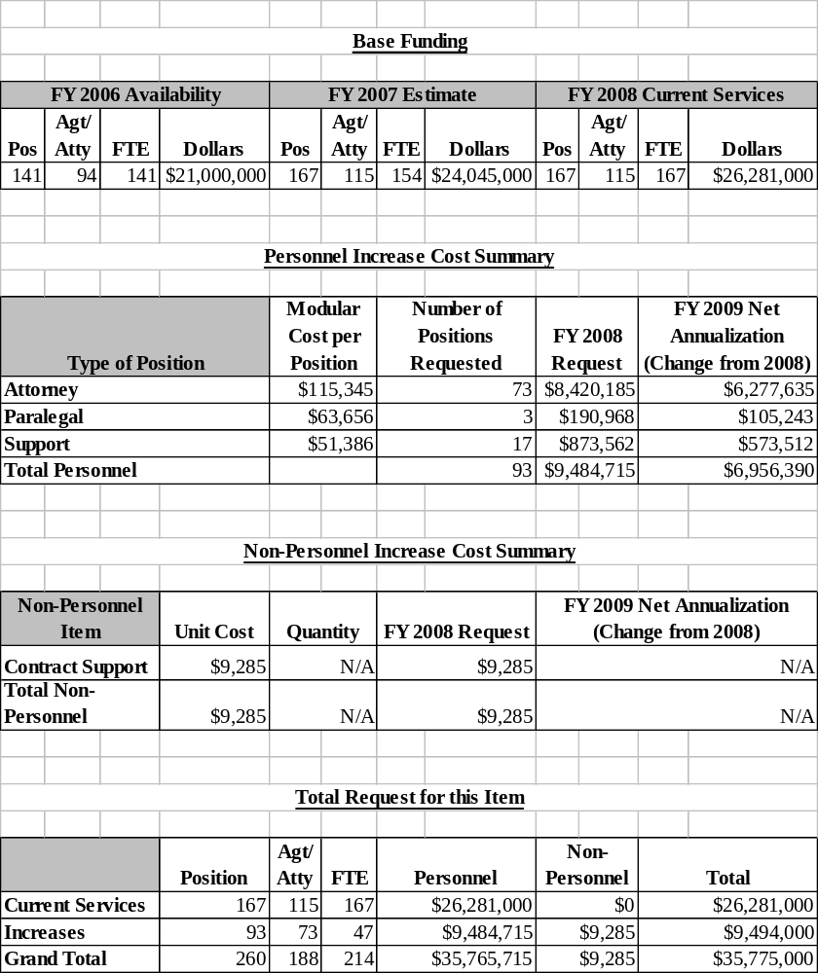

B. CIVIL

United States Attorneys
Salaries and Expenses
(Dollars in Thousands)

Civil Litigation | Perm. Pos. | Workyears | Amount
2006 Enacted w/Rescissions and Supplementals | 2,136 | 2,219 | $335,956
2007 Estimate | 2,142 | 2,225 | $349,821
Adjustments to Base and Technical Adjustments | ... | ... | 17,545
2008 Current Services | 2,142 | 2,225 | $367,366
2008 Program Increases | ... | ... | ...
2008 Offsets
2008 Request | 2,142 | 2,225 | $367,366
Total Change 2007-2008 | ... | ... | $17,545

1. Program Description–Civil Decision Unit

Civil litigation pursued by the United States Attorneys (USAs) falls into two basic categories: affirmative litigation, where the United States is the plaintiff, and defensive litigation, where the United States is the defendant. Affirmative litigation cases are actions taken by USAs to assert and protect the government’s interests, and they include such issues as the enforcement of the nation’s environmental, admiralty, and civil rights laws, as well as the recovery of damages done to the government through fraud. USAs also use affirmative litigation to recoup money owed and recover damages done to the government. Defensive litigation cases are lawsuits brought against the government by those who allege suffering due to government actions, and they include such issues as the adjudication of Social Security disability claims, alleged contract violations, and alleged race, sex, and age discrimination. USAs may also be called upon to represent the United States in cases which are not clearly defined as either affirmative or defensive litigation but in which the government has an interest, such as bankruptcy cases in which the United States is a party.

One key difference between affirmative litigation cases and defensive litigation cases is that while USAs have some discretion in deciding which affirmative cases they will pursue, USAs must defend the government in all defensive litigation cases. Due to the fact that the federal government’s obligations in the area of defensive litigation are non-delegable, the amount of resources remaining to pursue affirmative litigation cases by United States Attorneys’ Offices (USAOs) has resulted in a substantial decrease in cases filed in this area, as shown in the data below.

Affirmative civil cases can bring in substantial resources to the federal government as USAOs collected $3.72 billion in civil debts in FY 2006. In recent cases, Gambro Healthcare agreed to pay $310 million to resolve civil liabilities stemming from alleged kickbacks paid to physicians and payments made to a sham medical equipment company. GalxoSmithLine (GSK) agreed to pay the government $150 million to settle charges it violated the False Claims Act in a scheme to increase market share by reporting false and misleading information about the price of two anti-nausea drugs.

Civil matters and cases represent a significant part of the USAs’ workload. In FY 2006, USAs received 80,760 civil matters, which represented 42 percent of the 191,453 criminal and civil matters received during the fiscal year. Of the civil matters received, 50,853 or 63 percent were defensive matters, 12,675 or 16 percent were affirmative matters, and 17,232 or 21 percent were other civil matters. USAs filed or responded to 71,402 civil cases in FY 2006, which represented 55 percent of the 130,104 criminal and civil cases filed during the fiscal year. Of the civil cases filed, 49,701 or 70 percent were defensive cases, 7,109 or 10 percent were affirmative cases, and 14,592 or 20 percent were other civil cases.

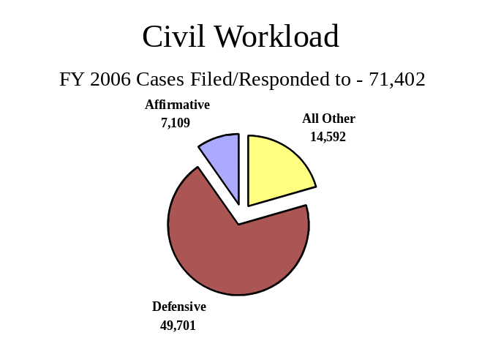

Between FY 2003 and FY 2006, the number of civil cases filed or responded to decreased by 10,533 or 13 percent from 81,935 cases to 71,402, while the number of civil cases referred to USAs decreased by 9,199 or 10 percent from 89,959 in FY 2003 to 80,760 cases in FY 2006. As a result, the number of defensive civil cases filed has decreased by 4,507 or 8 percent from 54,208 cases in FY 2003 to 49,701 in FY 2006. The number of affirmative cases filed has decreased by 1,841 cases or 21 percent, from 8,950 cases in FY 2003 to 7,109 in FY 2006.

In FY 2006, 98 percent of all judgments in affirmative civil cases were in favor of the United States, the highest favorable judgment rate of all case classes. Through affirmative litigation, USAs collected $3.72 billion in civil debts owed to the United States, more than twice the amount the U.S. Attorneys’ FY 2006 budget and an increase of $1.34 billion or 56 percent over the amount of debts collected in FY 2005.

2. Performance, Resources, and Strategies

The civil decision unit contributes to the Department’s Strategic Goal 2: Enforce Federal Laws and Represent the Rights and Interests of the American People. Within this goal, the decision unit’s resources specifically address two of the Department’s Strategic Objectives: 2.4 - uphold the civil and Constitutional rights of all Americans, and protect vulnerable members of society; and 2.5 - enforce federal statutes, uphold the rule of law, and vigorously represent the interests of the United States in all matters for which the Department has jurisdiction.

a. Performance Plan and Report for Outcomes

Prosecution of civil litigation is an essential and vital component of the mission of the U.S. Attorneys. Civil cases are used to prosecute fraud, waste, and abuse in federal programs and ensures the government is fully compensated for the losses and damages caused by those who have enriched themselves at the government’s expense. In addition, all lawsuits filed against the
government must be defended. USAs represented the government in 49,701 defensive civil cases that were filed in court during FY 2006. The U.S. Attorneys’ success in civil litigation preserves taxpayers’ dollars through affirmative and defensive litigation and ensures meeting the requirements and intent of federal laws and programs.

The performance measure for civil litigation relates to the percent of judgments and settlements resolved in favor of the government. The target for FY 2006 was 85 percent and the actual figure was 83.8 percent. The performance goal for FY 2007 and FY 2008 is to reach an 85 percent favorable resolution rate.

b. Strategies to Accomplish Outcomes

The challenge is to maintain the favorable resolution rate of 85 percent through the use of efficiencies with existing resources. Productivity will be increased through improved technologies and litigation support services, providing resources for continued support to pursue discretionary cases, such as the affirmative litigation caseload. These cases often bring in substantial revenue to the Government, providing a positive return on the investment of resources to bring these cases.

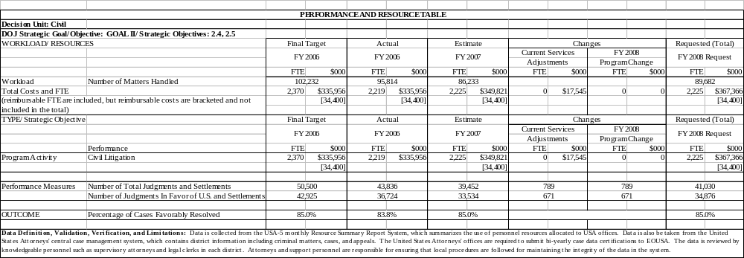

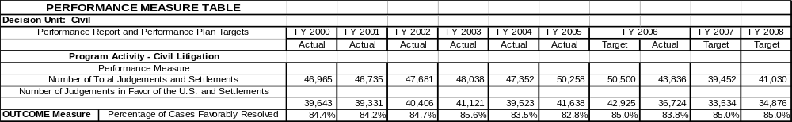

C. LEGAL EDUCATION

United States Attorneys
Salaries and Expenses
(Dollars in Thousands)

Legal Education | Perm. Pos. | Workyears | Amount
2006 Enacted w/Rescissions and Supplementals | 38 | 39 | $17,825
2007 President’s Budget | 41 | 40 | $19,275
Adjustments to Base and Technical Adjustments | ... | 2 | 473
2008 Current Services | 41 | 42 | $19,748
2008 Program Increases | ... | ... | ...
2008 Offsets
2008 Request | 41 | 42 | $19,748
Total Change 2007-2008 | ... | 2 | $473

1. Program Description–Legal Education

The Office of Legal Education (OLE) develops, conducts, and authorizes the training of all federal legal personnel [28 C.F.R. §0.22 (1990)]. OLE coordinates legal education and attorney training for the Department of Justice (DOJ) and other departments and agencies of the Executive Branch. Virtually all of OLE’s classroom training is conducted at the National Advocacy Center (NAC), a premier federal training facility in Columbia, South Carolina. The NAC features an integrated instructional and residential facility augmented by a conference and research center with student and support services on site.

Continuing legal education credit is provided through OLE for many OLE-sponsored courses. OLE is the primary source of instruction for DOJ attorneys and Assistant United States Attorneys (AUSAs) from the 94 USAOs. Basic programs for newly hired attorneys include criminal, civil, and appellate advocacy; federal practice seminars; and specialty courses in priority substantive areas of the law. Advocacy skills programs are available to new and advanced trial attorneys. The Federal Practice Program is designed for attorneys with litigation experience who are new to the federal civilian legal system (e.g., former state and military prosecutors), and as continuing training for Department attorneys after the basic criminal, civil, and appellate advocacy courses.

OLE uses experienced federal trial and appellate attorneys as instructors for all its programs to present lectures, lead discussion groups, direct evidentiary exercises, and offer personalized critiques. Federal judges also participate in OLE's advocacy courses, presiding over mock trials and mock appellate arguments. The caliber of the OLE faculty and the use of sophisticated videotaping facilities provide students with unique training experiences in trial and appellate advocacy. A significant feature of the advocacy training is the use of "learn-by-doing" exercises which concentrate on courtroom skills. These exercises simulate courtroom activities and provide students with classroom critiques and individual video replay analysis. Finally, OLE has met the high demand for attorney management training for senior criminal and civil attorneys by providing management courses for attorney supervisors of all levels.

OLE conducts programs on federal, civil, and administrative law practices for attorneys in the Executive Branch, including those in the Department of Justice. OLE offers training in civil discovery and trial techniques; negotiation techniques; and administrative law areas such as bankruptcy, the Freedom of Information Act, ethics, environmental law, federal employment, regulatory processes, government contracts, legal research and writing for attorneys, management of attorneys, and computer crime. Course instruction emphasizes the realities of federal practice. Federal attorneys from every agency, including the Department of Justice, are participants as well as advisors, curriculum developers, lecturers, and instructors. Most instructors come from a cadre of federal prosecutors. On a few occasions, OLE also contracts with professional educators as instructors for these courses.

OLE develops and administers paralegal courses covering basic and advanced skills in civil, criminal, and appellate practice. Training for other support staff personnel (e.g., legal secretaries, systems managers, etc.) in USAOs is provided through OLE, which develops the curriculum, recruits instructors, and assists local offices with administering the courses.
OLE operates a videotape lending library for USAOs and federal agencies. In addition, commercially produced tapes by recognized legal experts have been purchased by OLE, and the tapes are sent to offices upon request to supplement their in-house training programs. The completion of a video production studio at the National Advocacy Center (NAC) has provided the capability to produce videotapes and other distance education materials. This has increased the number of tapes available and enhanced the ability to keep videotaped presentations current by updating them to include recent legislation, policy changes or court decisions. In addition, during FY 2006, OLE began using podcasts on an experimental basis as a further method for distributing materials.

OLE began the Justice Television Network (JTN) during FY 2001. JTN is a satellite-based system that provides training and news to the 93 United States Attorneys' offices (USAOs), as well as branch offices. The JTN schedule includes 40 hours of programming each week, and a 15 hour "re-feed" to the West Coast each workday.

2. Performance, Resources, and Strategies

The Legal Education decision unit contributes to the Department’s Strategic Goal I: Prevent Terrorism and Promote the Nation’s Security. Within this goal, the decision unit’s resources specifically address two of the Department’s Strategic Objectives: 1.1- Prevent, disrupt, and defeat terrorist operations before they occur; and 1.2 - Investigate and prosecute those who have committed, or intend to commit, terrorist acts in the United States.

The Office of Legal Education also contributes to Goal II: Enforce Federal Laws and Represent the Rights and Interests of the American People. Within this goal, the decision unit’s resources specifically address five of the Department’s Strategic Objectives: 2.1 - Reduce the threat, incidence, and prevalence of violent crime, including crimes against children; 2.2 - Reduce the threat, trafficking, use, and related violence of illegal drugs; 2.3 - Combat white collar, economic crime, and cybercrime; 2.4 - Uphold the civil and Constitutional rights of all Americans, and protect vulnerable members of society; and 2.5 - Enforce federal statutes, uphold the rule of law, and vigorously represent the interests of the United States in all matters for which the Department has jurisdiction.

a. Performance Plan and Report for Outcomes

As illustrated in the Performance and Resource Table, the performance outcome measure for this decision unit is the number of students trained. In FY 2006, OLE trained 21,491 people, compared to 16,913 in FY 2005. Of the total number trained in FY 2006, 13,181 students were trained in 206 classroom courses, 2,704 received CLE credit for JTN training; 1,782 were trained through OLE’s videotape lending program; and 3,824 were trained in courses co-sponsored by OLE in U.S. Attorney Offices around the country. In addition, in FY 2006 OLE trained approximately 220 state and local prosecutors in live courses covering issues of importance to federal, state, and local prosecutors. This compares to approximately 200 state and local prosecutors trained in FY 2005.
The total number of students trained in combined classroom and satellite training was 21,491 in FY 2006, compared with the planned level of 16,000. In FY 2007, the number of students planned to be trained will be 19,342, and that number will rise to 20,116 in FY 2008.

Since the opening of the NAC in April 1998, OLE has engaged in a collaborative effort with the National District Attorneys Association (NDAA) and the Executive Office for United States Trustees to create a premier training center that brings together federal, state, and local prosecutors to train in a state-of-the-art facility. Training for NDAA personnel is paid for through a grant administered by the Office of Justice Programs.

The Publications Unit of the Office of Legal Education edits and publishes the United States Attorneys’ Manual, the United States Attorneys’ Bulletin, and a number of practical skills manuals. During FY 2006, the OLE Publications Unit published six issues of the United States Attorneys' Bulletin. OLE also published a revision to Prosecuting Intellectual Property Crime, and reprinted and distributed several other books from OLE’s “Blue Book” series. The unit procures and distributes the United States Sentencing Commission Guidelines Manual to U.S. Attorney Offices. This unit also produces the USA Book Online Library, which has now grown to include hundreds of policy manuals, textbooks, and monographs and has become a federal practice encyclopedia. The CD-Rom version of the online library is used by Department attorneys and investigators working at home, on travel, on detail, or whenever they do not have access to the Department’s Intranet.

b. Strategies to Accomplish Outcomes

The U.S. Attorneys will continue to ensure that a high quality legal education program is available for basic and advanced legal training through traditional classroom instruction and expanded use of JTN and distance learning. Additional training will need to be provided for new initiatives such as immigration; gangs; and child exploitation and obscenity prosecutions.

